09/09/2024
New game proposal.
- Develop on flutter, mobile game.
- 2.5 d environment
- 3d objects

Attractive points:
- Choice Tree
- Freedom: building base
- Inventory system
- Leveling up
- Physix engine
- Specific hitbox and scars
Theme:
Unending quest (mobile in app purchase & ads)
Trade but in space:
Start in milky way galaxy:
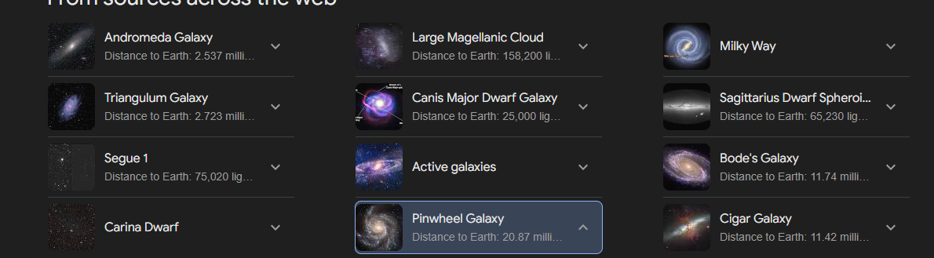
Unlock galaxies with updates:Watch cowboy bepop and draw inspiration
Trade winds
Perk tree backstory: trader, pirate, bounty hunter
Puzzles for each backstory and treasure hunting on specific islands.

